Project Design Phase-II
Data Flow Diagram & User Stories

Date | 19-02-2026
Team ID | LTVIP2026TMIDS66321
Project Name | Cafeteria menu display
Maximum Marks | 4 Marks

Data Flow Diagrams:
In the cafeteria menu display system, the cafeteria admin updates menu items, prices, and availability through a control interface, and the system processes and stores this information in a database. The digital menu display then retrieves the updated data in real time from the database. Finally, customers view the accurate and updated menu information on the cafeteria display screen, enabling faster and clearer decision-making.
Example: (Simplified)
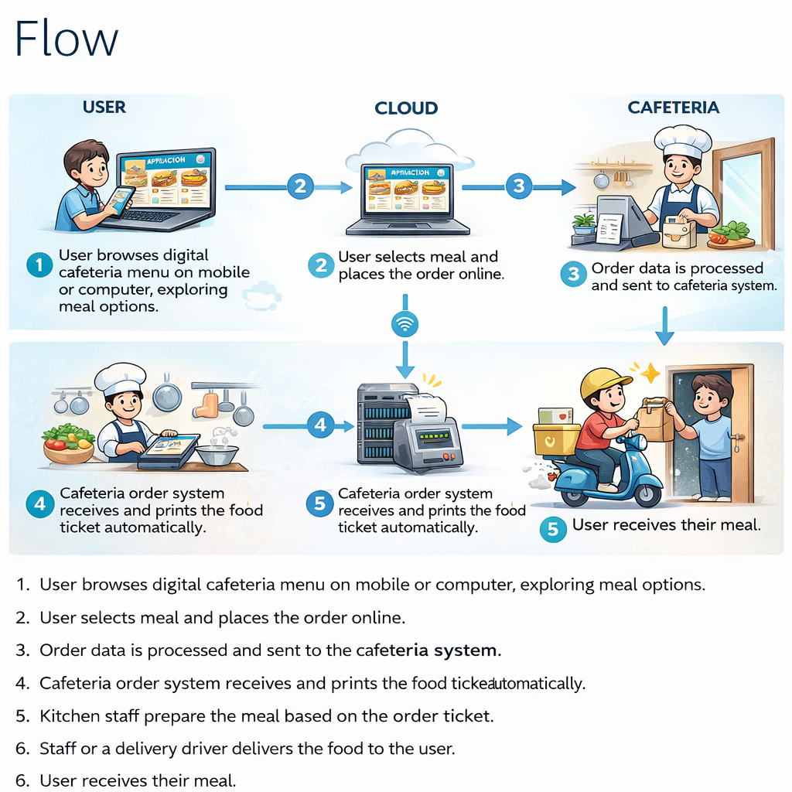
Example: DFD Level 0 (Industry Standard)

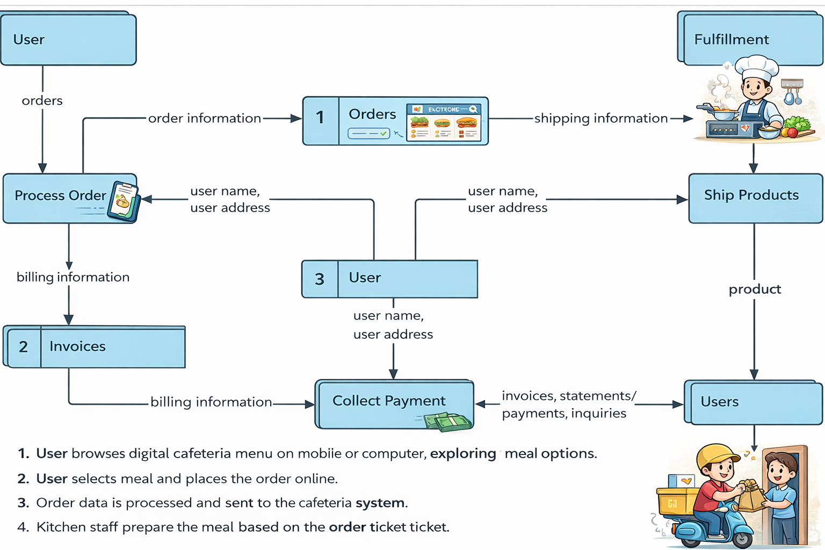
User Stories
Use the below template to list all the user stories for the product.
User Type | Functional Requirement (Epic) | User Story Number | User Story / Task | Acceptance criteria | Priority | Release
Customer | Menu viewing | USN-1 | As a customer, I want to view the daily menu on a digital display so I know what is available. | Menu displays current date, meal items, and prices clearly. | High | Sprint-1
Customer | Dietary info | USN-2 | As a customer , I want to see an allergen and calorie info for each item to make healthy choices. | Icons for vegan, gluten-free and calorie counts are visible next to items. | Medium | Sprint-1
Cafeteria staff | Menu Management | USN-3 | As a staff member, I want to update the menu in real-time if an item runs out. | Staff can mark items as sold out via a mobile or web interface. | High | Sprint-1
Cafeteria staff | Scheduling | USN-4 | As a staff member, I want to schedule menus for the entire week in advance. | System allows inputting and saving a distinct menus for Mon-Fri. | Medium | Sprint-2
Admin | System config | USN-5 | As an admin, I want to customize the display theme and layout to match branding. | Admin can change colours, logos, and font sizes through the dashboard. | Low | Sprint-2
Customer | Wait times | USN-6 | As a customer, I want to see estimated wait times for different food stations. | Real-time wait estimates are displayed based on current order volume. | medium | Sprint-3
Customer | Menu interaction | USN-7 | As a customer, I want to scan a QR code on the display to view the menu on my phone. | A dynamic QR code is generated on screen, scanning it opens the current live menu URL. | High | Sprint-2
Customer | Feedback | USN-8 | As a customer, I want to rate a meal directly on the display or via phone to share my preference. | System captures 1-5 star ratings and optional text comments for each dish. | Low | Sprint-3
Customer | Accessibility | USN-9 | As a visually impaired user, I want the digital menu to have high contrast mode options. | A physical button or touch icon toggles high contrast/large text mode on the screen. | High | Sprint-2
Kitchen staff | Specials/promos | USN-10 | As a manager, I want to highlight “chef’s specials” with animations to increase sales | Admin can toggle a “Highlight” flag that add a pulsing border or badge to specific items. | Medium | Sprint-1
Administrator | Analytics | USN-11 | As a admin, I want to see which menu items were viewed the most to plan future menus. | Dashboard provides a report on “Menu clicks” or “QR scans” per item. | Medium | Sprint-3
Administrator | Hardware control | USN-12 | As a admin, I want to schedule the display to turn off automatically after cafeteria hours. | A “Sleep/Wake” timer allows setting specific hours for the display hardware to save energy. | Low | Sprint-3

